64-73 Mustang Instructions
Colt 65 Kit Includes

K-Member w/ Engine Mounts
A-Arms
Caster Camber Plates
Universal coil-over strut assembly with springs.

Kit requires:

- 87-93 V8 Spindles and Brakes or 94-04 Spindles and Brakes
- 79-93 Rack & Pinion
- Aftermarket Steering Shaft Kit
- Bump-steer Kit

Full kits include Colt 65 kit plus fabricated spindles, rack & pinion, bump steer kit, and steering shaft

Besides the normal mechanics tools of sockets, wrenches, etc. you will need the below additional tools:

- Safety glasses
- Jack and jack stands
- Large hammer and cold chisel
- Spray lubricant such as PB Blaster, WD 40, etc.
- Engine degreaser
- Locking Pliers
- Torque wrench
- Loctite blue (recommended)
- Center punch
- Ball joint separator tool
- Good quality coil spring compression tool
- Pry bar
- Large adjustable wrench
- Sharpie marking pen
- Masking/painters tape with a straight edge and tape measure or straight edge rule?
- Rags or paper towels
- Power drill and 1/8”, ½” and ¾” drill bits
- Spot weld removal tool(s). There are highly recommended but not required. The spot weld cutter will allow for an easier and cleaner removal of the spot-welded components. A good auto body parts distributor will carry a spot weld cutting tool. This will be used in a drill, whether cordless or plug-in electric. If used carefully, an angle grinder can be used instead of the spot weld cutter.

It is recommended to thoroughly clean the installation area prior to beginning. This will make locating the various attaching hardware and spot welds easier.

For ease of installation, it is recommended that the engine and transmission be removed but is not required. If the engine will remain in the car, an engine support beam must be used to support the engine securely from the top.

- Position the car on a solid, level and flat surface. Raise the car and SAFELY support it using jack stands.

- If the engine is still installed in the car, disconnect the battery.

- Remove the front wheels.

- From inside the wheel well, removing the six bolts securing the skirt around the spring and shock assembly.

REMOVAL HUB ASSEMBLY

- Disconnect and plug the brake hoses from the brake drum/caliper. Use plenty of rags or paper towels to control any spills of brake fluid. Dispose of used rags/paper towel properly after use.

CAUTION:
Brake fluid is toxic. It will also remove paint.
If brake fluid is spilled, clean up immediately.

- Place a jack under the lower control arm and raise it to compress the spring slightly.

- Using the spring compression tool, CAREFULLY compress the coil spring as much as necessary to remove it.

WARNING:
INJURY OR DEATH CAN RESULT IN NOT TREATING COMPRESSED COIL SPRINGS WITH UTMOST RESPECT. THERE IS A GREAT AMOUNT OF STORED ENERGY IN A COMPRESSED COIL SPRING AND ARE CAPABLE OF DOING DAMAGE TO YOU, YOUR CAR AND PROPERTY IF NOT PROPERLY REMOVED.

- Once the spring is safely compressed, remove the two bolts securing the upper shock mount to the shock tower cap.

- Remove the three nuts and bolts securing the shock tower cap to the shock tower.

- If equipped, remove the hardware attaching the upper export brace to the fire wall and remove the export brace.

- Remove the lower two nuts and bolts securing the shock body to the upper control arm and remove the shock assembly thought the top on the shock tower.

- Carefully lower the supporting jack from under the lower control arm.

- The compressed spring can be carefully removed from the car now.

- Remove the cotter pins and castle nuts from the lower ball joint and tie rod end.

- Using the ball joint separator tool, detach the lower control arm ball joint and tie rod end. Swing the lower control arm down.

- Remove the cotter pin from the upper control arm ball joint. Loose the nut a few turns but do not remove it from the ball joint stud at this time.

- Using the ball joint separator tool, detach the upper control arm ball joint.

- Support the steering knuckle assembly (heavy). Remove the nut securing the upper ball joint and carefully lower and remove the whole assembly.

- From inside the engine bay, remove the two bolts attaching the upper control arm to the shock tower. Remove the upper control arm.

LOWER CONTROL ARMS REMOVAL

- Remove the large nut securing the radius arm to the front of the radius arm pocket.
ALTERNATE: The whole radius arm can be removed by removing the two nuts attaching the radius arm to the lower control arm and the large nut securing the radius arm to the front of the radius arm pocket.

- Remove the sway bar link hardware from the sway bar end. This hardware will not be used again in this installation.

- Remove the nut and bolt securing the control arm end to the chassis pivot pocket. The control arm itself could difficult to remove. Soak with WD40, PB Blaster, etc. and use the pry bar or hammer as needed.

- Using the ball joint separator tool, remove the rod end attached to the steering box pitman arm.

- Remove the attaching hardware from the steering box rag joint.
NOTE: Prior to 1967, the steering box will have a full length steering input shaft. The whole steering column will have to be removed prior to the removal of the steering box.
Reference the factory manuals for the proper step-by-step to remove/replace the steering column. WHAT ABOUT MODING THE STEERING INPUT SHAFT ON 1967 AND PRIOR??

- Remove the attaching hardware securing the steering box to the frame and remove the steering box.

- Depending on manufacturer’s requirements, there may or may not be a cross member between the lower shock towers. Remove the attaching hardware and remove the cross member.

SHEET METAL REMOVAL

There will be several spot welds that will need to be cut on the OEM sheet metal components that will need to be removed. If using the spot-weld cutter, be careful not to cut too deep, this will only add to any repair and finish work. Read and follow the directions included with the cutters for best results.
If using an angle grinder to break spot welds, be careful to use the edge of the wheel only and grind only deep enough to break the weld. A hammer and cold chisel may have to be used on some spot-welds as various other tools, pry bar, locking pliers, etc.

NOTE: If using a spot weld cutter, it is recommended to center punch each of the spot welds prior to cutting. This will prevent the spot weld cutter from “walking” off of the spot weld.

- From inside the shock tower, locate, mark and cut all the spot-weld securing the spring pocket ring that locates the top of the coil spring in the shock tower.

- From under nether the car, locate, mark and cut all the spot-weld securing the lower control arm pocket/motor mount.

- Carefully look over the entire area where the OEM sheet metal components were removed and clean up any barbs, shards, or ragged edges of metal left by the spot weld removal. Now is the time to make any structural repair if necessary.

MOUNTING THE K-MEMBER

ASSEMBLY

- Carefully lay out the all the parts in front of the car to make sure all the AJE components are there. If there are any questions or concerns, call the AJE tech line at 812-346-7356 or 800-877-7233,

K-MEMBER

- Position the K-member under the front of the car.

- On the inside of the frame rail locate the two holes that were used by Ford to align the front suspension. The center distance between these holes pictured below should indicate your spindle center line. The mounting locations on K-Frame is 8 inches apart, the center distance between the two holes should be marked at 4 inches.

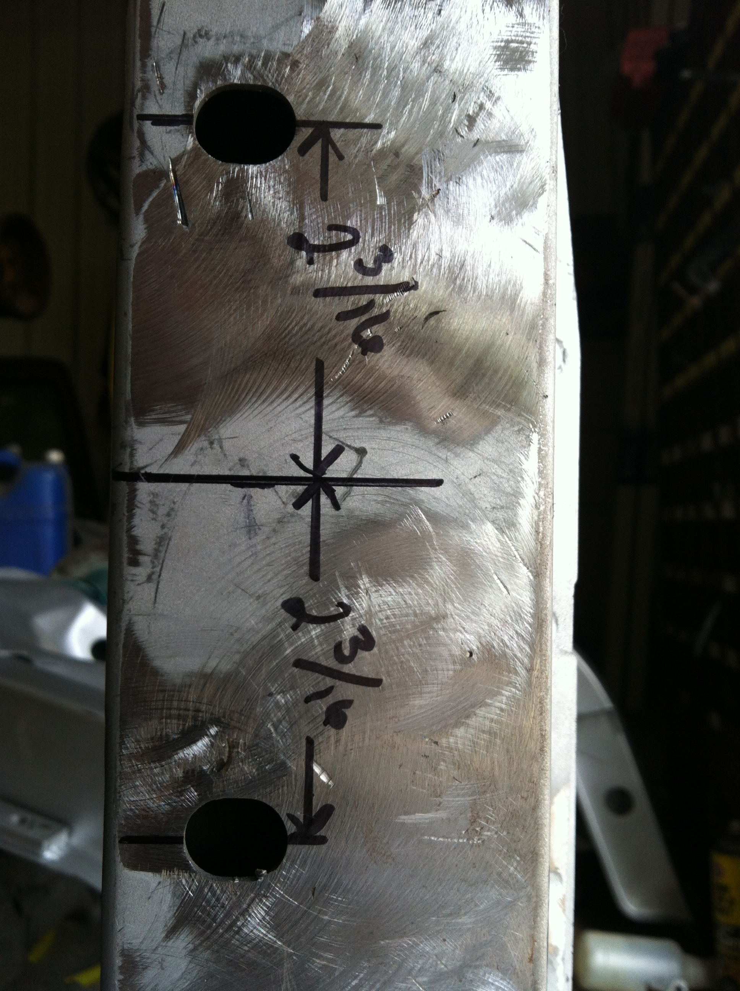
Place a small piece of tape on the inside of the K-member rails and find the center by measuring as shown in photo.

- When you find the center, mark the frame rails with a center punch and drill the holes through the frame rail starting with a 1/8” bit. Enlarge the hole using a ½” bit. Then finally use a ¾” bit too enlarge one side of the frame rails.
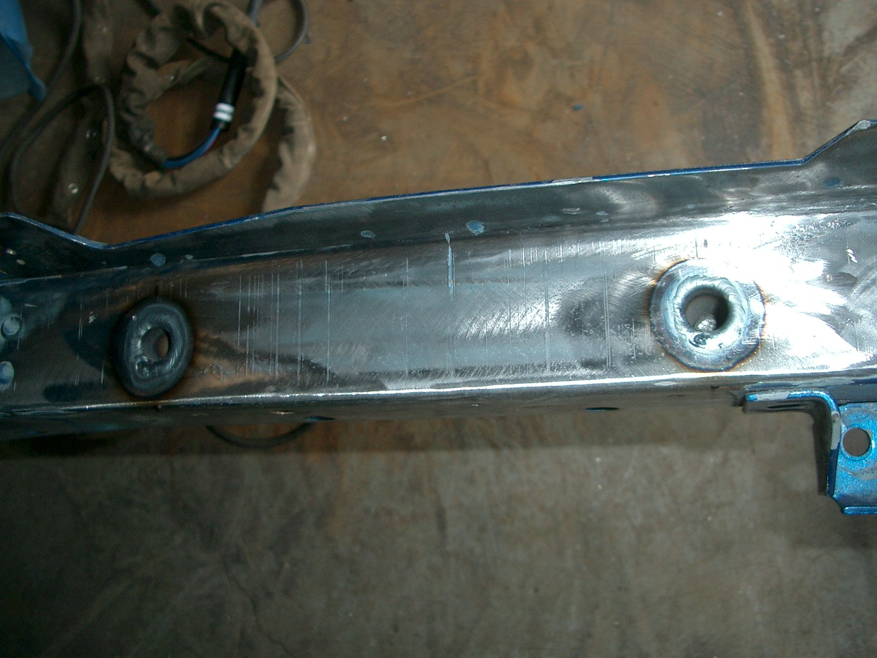
WARNING:
THE KIT CONTAINS FOUR CRUSH SLEEVES, TWO FOR FRAME SIDE. THESE CRUSH SLEEVES ARE REQUIRED TO BE INSTALLED AND ARE NECESSARY TO PREVENT THE FRAME RAIL FROM COLLAPSING WHEN THE MOUNTING BOLTS ARE TIGHTENED.

- Locate the K-member on the crush sleeves and loosely secure it with the bolts and nuts.

- Using the tape measure or ruler, set the overhang on each side the same, front to rear and side to side. This will center the K-member in the chassis.

- After the K-member is square and centered tighten all four bolts to insure it is securely in place. Torque the attaching hardware to 50-55 lb/ft.

- Install the A-arms. They can only go in one way, ball joint stud facing upward. Put rear pivot point in first. You may have to persuade the front into place, it is normal for it to be tight.

- Install the Caster-Camber Plates and strut assembly.
- Put the CC Plates in from the bottom. They will go in only one way with bolts through the shock tower.

- Locate the export brace onto the top of the shock tower and CC attaching. Temporarily snug the nuts.

- Locate the export brace onto the firewall and snug these fasteners.

- Place the steering knuckle (spindle) onto the ball joint. If using one of our Bump steer kits on stock spindles drill steering arm out too 5/8”.

- A thick washer supplied on the ball joint may be needed under the castle nut to raise it to where cotter pin fits into a slot.

- Insert the strut shaft through the CC Plate. There will be a nut threaded with the sleeve passing through the bearing or spacers (double adjustable Viking studs) for the CC Plate.

- Attach the strut to the steering knuckle using the lower mounting hole at this time only. Temporarily tighten the bolts.

- Mount the steering rack onto the K-member and torque the mounting bolts to 45-50 lb/ft.
The mounting hardware can be found attached to the K-member for shipping. Remove this hardware and insert the bushings and sleeves to the rack.

- Install the tie rod ends/bump steer kit. Thread the tie rod end onto the rack’s outer tie rod.

- To avoid bump steer, the tie rod end should set very near parallel to the lower arm. The number or configuration of shims depend on many variables so no two set ups are alike.

. The choice of components will determine how they will be assembled. AJE strut assemblies have been designed to get the most out of these components.

- The UPPER mounting hole on each AJE strut assembly will have a T-shaped hole with a slot. The accompanying hardware will include a key washer with an offset hole. This will allow you to dial in your camber.

